

A Course End Project Report on
Duplicate Data Removal System

A9513- Python Programing Language Laboratory

Submitted by
Charan – 25881A0577
Karthika – 25881A0587

Course Facilitator

Ms P.S.Madhavi
Assistant Professor

Department of Computer Science and Engineering Vardhaman College of Engineering, Hyderabad



Autonomous Institute, Affiliated to JNTUH,
Approved by AICTE, Accredited by NAAC with A++ Grade Kacharam, Shamshabad, Hyderabad- 501 218, Telangana, India.

DEPARTMENT OF COMPUTER SCIENCE AND ENGINEERING

This is to certify that the Course End Project titled “Duplicate Data Removal System” is carried out by Charan , Karthika with Roll Numbers 25881A0577,25881A0587 towards A9513 – Python Programing Language Laboratory course in partial fulfilment of the requirements for the award of degree of Bachelor of Technology in Computer Science and Engineering during the Academic year 2025-26.

Signature of the Course Faculty
Ms P.S.Madhavi
Assistant Professor, CSE
Signature of the HOD Dr.Y.Vijayalata Professor,Head of the Department & Dean(Student Mentoring ,
CSE

Contents
- Introduction 3
- Literature Review 3
- Objectives 3
- Methodology 3
  - Architectural Diagram 3
  - Hardware and Software Requirements 3
  - Working Principle 4
  - Software Implementation 4
- Results and Discussion 4
- Mapping POs ,PSOs and SDGs 5
  - Program Outcomes (POs) Mapping 5
  - Program Specific Outcomes (PSOs) Mapping 5
  - Sustainable Development Goals (SDGs) Mapping 5
- Conclusion 5
Bibliography 6

Abstract

The Duplicate Data Removal Tool is a Python-based application designed to identify and remove duplicate rows from structured datasets. The tool supports both CSV and Excel (XLSX) files, allowing users to select an input file through a simple Tkinter file-selection dialog. The selected data is loaded into a Pandas DataFrame, where duplicate rows are automatically detected and removed using the drop_duplicates() function.

After cleaning, the user can choose the desired output location and save the processed data as either a CSV or Excel file. The application also displays a summary containing the original number of rows, cleaned number of rows, number of duplicates removed, and the location of the cleaned file. The project demonstrates the practical application of Python, Pandas, Tkinter, file handling, and data-cleaning techniques to automate a common data-processing task.

Keywords: Duplicate Data Removal, Python, Pandas, Tkinter, CSV, Excel, Data Cleaning, DataFrame, Duplicate Rows, File Processing.

Introduction

In today's digital environment, large amounts of data are generated and stored in the form of spreadsheets and structured files. During data entry, collection, merging, or repeated importing of records, the same information may be stored multiple times. These duplicate records can increase the size of datasets and may lead to inaccurate results during data analysis and reporting.

The Duplicate Data Removal Tool is developed to provide a simple and automated solution for identifying and removing duplicate rows from structured datasets. The application accepts both CSV and Excel (XLSX) files as input and processes them using Python. It uses the Pandas library to read the data into a DataFrame and efficiently remove duplicate rows.

The tool also provides a simple file-selection interface using Tkinter, allowing users to select the input file and choose the location and format of the cleaned output file. After processing, the application displays the original number of rows, cleaned number of rows, number of duplicates removed, and the location of the saved file.

The project demonstrates the practical use of Python programming, Pandas, Tkinter, file handling, DataFrames, and data-cleaning techniques to automate a common data-processing task. It provides a straightforward and user-friendly approach for preparing datasets for further analysis and use

- Literature Review

Data cleaning is an important stage in data preparation because the quality of the input data directly affects the accuracy and reliability of subsequent analysis. Duplicate records are one of the common data-quality problems that can occur due to repeated data entry, importing the same information multiple times, or combining data from different sources.

Various approaches have been developed to identify and remove duplicate records. Spreadsheet applications provide built-in facilities for detecting duplicate values, while database systems can use queries and constraints to control repeated records. However, these approaches may require manual operations or additional database knowledge when processing large datasets.

Python provides several libraries that simplify data-processing and cleaning tasks. Pandas is particularly useful for handling structured data through DataFrames. Its drop_duplicates() function provides a direct method for identifying and removing duplicate rows while retaining the required unique records.

The proposed Duplicate Data Removal Tool builds on these concepts by combining Pandas-based data processing with Tkinter file-selection and saving dialogs. The tool supports CSV and Excel files and provides an automated workflow for selecting data, removing duplicate rows, saving the cleaned dataset, and displaying the cleaning results. This approach reduces repetitive manual work and provides a simple practical application of data-cleaning techniques.

Objectives

The main objectives of the Duplicate Data Removal Tool are:
- To develop a Python-based tool for identifying and removing duplicate rows from structured datasets.
- To support multiple file formats, particularly CSV and Excel (XLSX), for input and output.
- To automate the data-cleaning process using the Pandas drop_duplicates() function.
- To provide a simple file-selection interface using Tkinter, making the tool easy to use without manually entering file paths.
- To generate a cleaned dataset while preserving the first occurrence of each unique row.
- To display processing statistics, including the original number of rows, cleaned number of rows, and number of duplicates removed.
- To reduce manual effort and errors involved in identifying and removing duplicate records from datasets.
- To demonstrate the practical application of Python programming, Pandas, Tkinter, and file-handling concepts in solving a real-world data-cleaning problem.

Methodology

Architectural Diagram

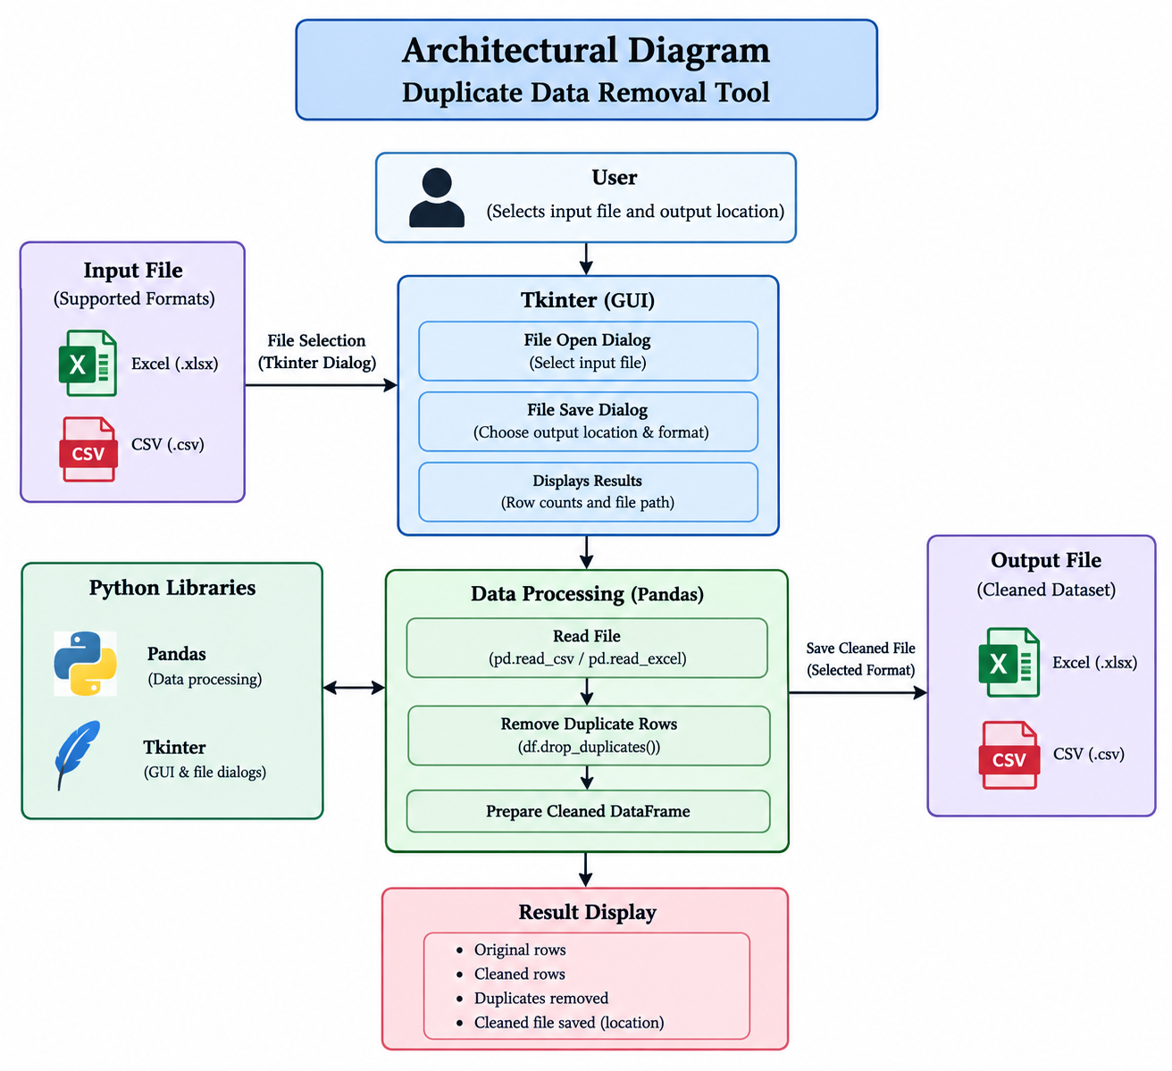
Figure 1: Architectural Diagram

The architecture of the Duplicate Data Removal Tool represents the flow of data from file selection to the generation of a cleaned dataset. The user first selects an input file in either CSV or Excel format using the Tkinter file-selection dialog. Tkinter provides the interface required for selecting the input file and specifying the location and format of the output file.

After the file is selected, the data is passed to the Pandas data-processing module. Pandas reads the selected file into a DataFrame using read_csv() for CSV files or read_excel() for Excel files. The DataFrame is then processed using the drop_duplicates() function, which identifies and removes duplicate rows while retaining the first occurrence of each unique row.

Once the duplicate records have been removed, the cleaned DataFrame is sent to the output module. The user can save the cleaned data as either a CSV or Excel file using the Tkinter save dialog. The system then displays the processing results, including the original number of rows, the number of cleaned rows, the number of duplicates removed, and the location of the saved file. Thus, the complete architecture provides a simple flow of input selection → data processing → duplicate removal → cleaned output → result display.

Hardware and Software Requirements

Hardware Requirements:
The Duplicate Data Removal Tool can be executed on a standard computer or laptop. A basic system with a dual-core processor or above is sufficient for running the application and processing CSV or Excel files. A minimum of 4 GB RAM is recommended for handling normal-sized datasets, while additional RAM can improve performance when processing larger files. The system should also have sufficient storage space for the input files and cleaned output files. A standard keyboard, mouse, and display are required for interacting with the application.
Software Requirements:
The tool is developed using Python 3.x and can be executed using an IDE such as Visual Studio Code. The Pandas library is used for reading, processing, and cleaning the datasets, while Tkinter is used for file-selection and save dialogs. The openpyxl library is required for reading and writing Excel (.xlsx) files through Pandas. The application supports CSV and Excel file formats for input and output.

Working Principle
The Duplicate Data Removal Tool works by reading a user-selected CSV or Excel file and identifying repeated rows within the dataset. First, the user selects the input file using the Tkinter file-selection dialog. Based on the file extension, the program uses pd.read_csv() for CSV files or pd.read_excel() for Excel files to load the data into a Pandas DataFrame.

After loading the data, the drop_duplicates() function is applied to the DataFrame. It compares the values of the complete rows and removes repeated rows while retaining the first occurrence of each unique row. The number of duplicates removed is calculated by comparing the original number of rows with the number of rows remaining after cleaning.
Finally, the cleaned DataFrame is saved to the location selected by the user. The output can be stored in either CSV or Excel format. The program then displays the original row count, cleaned row count, number of duplicates removed, and the saved file location, allowing the user to verify the result of the data-cleaning process.

Software Implementation

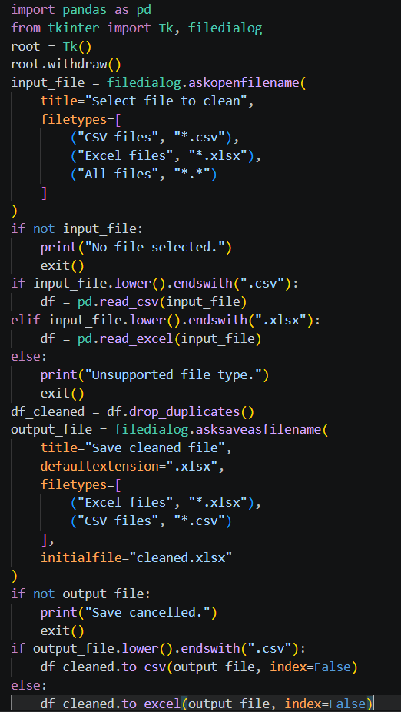

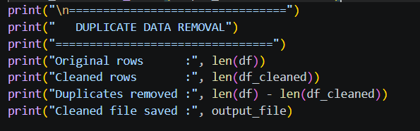

Results and Discussion

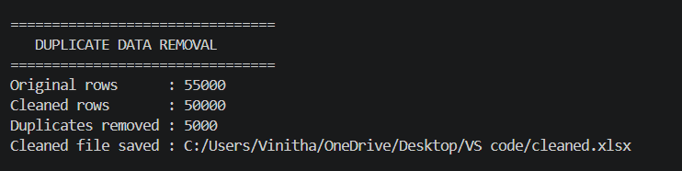

Summary of Results

The tool removes duplicate rows from CSV and Excel files using Python and Pandas. It successfully generates a cleaned dataset and displays the number of duplicates removed, reducing manual data-cleaning effort.

Interpretation

The results show that the Duplicate Data Removal Tool successfully identifies and removes repeated records from the dataset. The reduction in the number of rows indicates that duplicate entries were present in the original file. This demonstrates that the tool can effectively clean data and produce a more reliable dataset with less manual effort.

Achievement of Objectives

The objectives of the Duplicate Data Removal Tool were successfully achieved by developing a Python-based application that identifies and removes duplicate rows from CSV and Excel files. The tool uses Pandas for data processing and Tkinter for file selection and saving. It automatically generates a cleaned dataset and displays the number of duplicate records removed, thereby reducing manual effort and improving data-cleaning efficiency.

Implications
The Duplicate Data Removal Tool helps improve data quality by eliminating repeated records from datasets. It reduces manual effort, saves processing time, and produces cleaner data for further analysis and reporting. The tool can be useful for students, organizations, and users who frequently work ith CSV and Excel files.

- Mapping POs and SDGs

Program Outcomes (POs) Mapping
Table 1: Mapping of Program Outcomes (POs) to Project Relevance
PO | Program Outcome | Mapping with Project
PO1 | Engineering Knowledge | Applied Python programming, Pandas, DataFrames, and file-handling concepts.
PO2 | Problem Analysis | Identified duplicate records as a common data-quality problem and developed a solution.
PO3 | Design/Development of Solutions | Designed a workflow for selecting, cleaning, and saving datasets.
PO4 | Conduct Investigations | Tested the tool with datasets containing duplicate records and analyzed the results.
PO5 | Modern Tool Usage | Used Python, Pandas, Tkinter, CSV, and Excel processing tools.
PO8 | Individual and Team Work | Involved implementation, testing, documentation, and review of the project.
PO9 | Communication | Presented the project through documentation, diagrams, and results.
PO11 | Life-long Learning | Developed practical knowledge of data cleaning and automation using Python.

Program Specific Outcomes (PSOs) Mapping
Table 2: Mapping of Program Specific Outcomes (PSOs) to Project Relevance

PSO | Program Specific Outcome | Mapping with Project
PSO1 | Apply computer science fundamentals to develop software solutions. | The project applies Python programming, data structures, file handling, and data-processing concepts to develop a practical data-cleaning tool.
PSO2 | Use modern computing tools and technologies to solve real-world problems. | The project uses Python, Pandas, Tkinter, CSV, and Excel processing to automate duplicate-data removal.
PSO3 | Develop efficient and user-friendly software applications. | The tool provides a simple file-selection interface and automatically generates a cleaned dataset, reducing manual effort.

Sustainable Development Goals (SDGs) Mapping

Table 3: Mapping of Sustainable Development Goals (SDGs) to Project Relevance

SDG No. | Goal | Relevance
SDG | Sustainable Development Goal | Project Contribution
SDG 4 | Quality Education | Provides practical experience in Python programming, data processing, and automation.
SDG 7 | Affordable and Clean Energy | Promotes efficient digital processing by reducing unnecessary duplicate data and storage.

Conclusion

The Duplicate Data Removal Tool provides a simple and effective solution for identifying and removing duplicate records from CSV and Excel files. The tool uses Python and Pandas for efficient data processing and Tkinter for easy file selection and saving.

The project successfully automates the data-cleaning process, reduces manual effort, and generates a clean dataset for further analysis or reporting. It also displays useful information such as the number of original rows, cleaned rows, and duplicates removed. Overall, the project demonstrates the practical use of Python programming, data handling, file processing, and automation to solve a common real-world data-cleaning problem.

Bibliography

Python Software Foundation. Python 3 Documentation. Available at: https://docs.python.org/3/

Pandas Development Team. Pandas Documentation. Available at: https://pandas.pydata.org/docs/

Python Software Foundation. Tkinter — Python Interface to Tcl/Tk. Available at: https://docs.python.org/3/library/tkinter.html

McKinney, W. Python for Data Analysis. O'Reilly Media, 2022.

VanderPlas, J. Python Data Science Handbook. O'Reilly Media, 2016.

Rahm, E. and Do, H. H. “Data Cleaning: Problems and Current Approaches,” IEEE Data Engineering Bulletin, Vol. 23, No. 4, pp. 3–13, 2000.

Microsoft. Microsoft Excel Documentation and Support. Available at: https://support.microsoft.com/excel

